SAMPLE PROJECT – 4

FINANCIAL PRODUCT PREFENCE AND

CUSTOMER SATISFACTION

(GOTLA SHIVANI YADAV)

**AIM –**

The aim of the project is

* **To identify different demographic:** of customers such as basic demographics includes age, gender, marital status, employment status where geographical include the area from which the customers are and financial include their income level, their account balance. Those based on the data the segmentation of customers has to be done to identify the target customer in order to focus and advertise those segments to improve and retain and regain new customers.
* **Optimize product offerings:** Analyze product penetration rates to identify opportunities for product development or tailoring existing products to better suit specific demographics.
* **Improve customer satisfaction:** Measure customer sentiment towards each product and identify areas for improvement, ultimately enhancing the customer experience.
* **To identify churn rates by product vise:** to identify the percentage of customers who stop using a specific financial product within a given timeframe and there by understanding customer retention and identifying areas for improvement.

**FEATURES**

* ID-it is the uniquid id given to the customer
* Age- age of the customer
* Gender - gender of the customer (male, female)
* Education Level- what is the educational status of the customer
* Employment Status- employment status of the customer whether employed, unemployed, studying etc
* Marital Status-includes details whether the customer is married or single or widow
* Company- a bank through which customer took the financial products
* Area- determines whether customer is from urban, rural or semi urban
* Account Balance- amount a customer holds in his bank account
* Income Levels – income that a customer earns
* Checking Account- involve active participation of this financial product represents ‘1’ and non-active or non-usage is represented as ‘0’.
* Savings Account - involve active participation of this financial product represents ‘1’ and non-active or non-usage is represented as ‘0’.
* Credit Card- involve active participation of this financial product represents ‘1’ and non-active or non-usage is represented as ‘0’.
* Mortgage- involve active participation of this financial product represents ‘1’ and non-active or non-usage is represented as ‘0’.
* Customer Satisfaction (Checking) – customer satisfaction rating is recorded as per the product giving values as 5 highly satisfied ,4-satisfied ,3-as neutral, 2 -as not satisfied ,1 -highly unsatisfied.
* Customer Satisfaction (Savings) - customer satisfaction rating is recorded as per the product giving values as 5 highly satisfied ,4-satisfied ,3-as neutral, 2 -as not satisfied ,1 -highly unsatisfied.
* Customer Satisfaction (Credit Card)- customer satisfaction rating is recorded as per the product giving values as 5 highly satisfied ,4-satisfied ,3-as neutral, 2 -as not satisfied ,1 -highly unsatisfied.
* Customer Satisfaction (Mortgage)- customer satisfaction rating is recorded as per the product giving values as 5 highly satisfied ,4-satisfied ,3-as neutral, 2 -as not satisfied ,1 -highly unsatisfied.
* Churn Rate (Checking)- to identify the percentage of customers who stop using checking account within a given timeframe
* Churn Rate (Savings)- to identify the percentage of customers who stop using savings account within a given timeframe
* Churn Rate (Credit Card) -to identify the percentage of customers who stop using credit card within a given timeframe
* Churn Rate (Mortgage)- to identify the percentage of customers who stop using a mortgage within a given timeframe

**METHODOLOGY**

* Data collection – data is collected including various details to do analysis
* Visualization – a power dashboard is created using the data and different graphs for different metrics of data is represented
* Segmentation, predictive modelling of customer preference towards different products, churn rate analysis and other pattern analysis is done.

**OUTPUT**

A SUMMARY DASHBOARD IS CREATED IN POWERBI

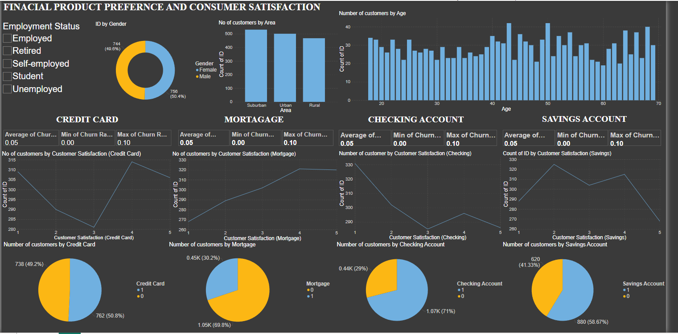

**OUTPUT ANALYSIS**

* A slicer was inserted to each employment status of a customer so based on the employment status the contribution towards each product is known as u click on the slicer

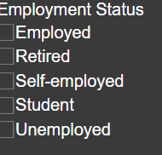

* This graph indicates the segments of women and men customer division so the count of id and gender is selected and a 3d pie chart is inserted indicating male and female contribution towards financial product preference and satisfaction obtained.

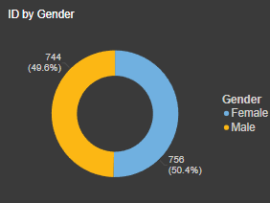

* This bar chart indicates area vies contribution of customer here it is absorbed that all the 3 areas customer contribution is important because the contribution is almost near by ratios a slight difference is there but so most contribution of customer belong to suburban area, and then urban then comes rural.

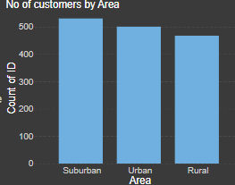

* This graph indicates different age groups customer count, it is seen that large number of customers are from age group of 43,50 and 69 which is almost above 40 for each.

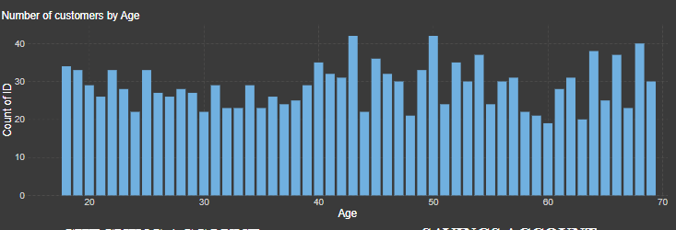

* This whole picture involves a line chart and pie chart and also details regarding the credit card churn rates.

1. Churn rates -average churn rate -.05

-min churn rate -0.00

-max churn rate -0.10

Churn rates determine the discontinuation or switching of customer from one product to another so based on these observations reason for the churn rates can be identified and can be reduced.

1. A line chart measuring the satisfaction of customer of the credit card so different rates of satisfaction is measured on scales whereas 5 highly satisfied ,4-satisfied ,3-as neutral, 2 -as not satisfied ,1 -highly unsatisfied .so we can say that the large number of customer are satisfied with the product and also a number of customer who are really unsatisfied give a rating 1 is equally high so we can identify the reason for their unsatisfaction and can give the best to the customer in order to reach max satisfaction to the customers
2. The next pie chart determines the participation rate of customers represented as 1,0 where 1 is identified as active and 0 as inactive. so here both active and inactive users are of same rates both positive as well as negative is of same pace

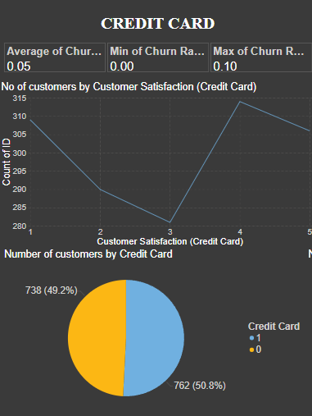

* This whole picture involves a line chart and pie chart and also details regarding the mortgage churn rates.

1. Churn rates -average churn rate -.05

-min churn rate -0.00

-max churn rate -0.10

Churn rates determine the discontinuation or switching of customer from one product to another so based on these observations reason for the churn rates can be identified and can be reduced.

1. A line chart measuring the satisfaction of customer of the credit card so different rates of satisfaction is measured on scales whereas 5 highly satisfied ,4-satisfied ,3-as neutral, 2 -as not satisfied ,1 -highly unsatisfied .so we can say that the large number of customer are satisfied with the product and also a very few number of customer who are really unsatisfied give a rating 1 so we can identify the reason for their unsatisfaction and can give the best to the customer in order to reach max satisfaction to the customers
2. The next pie chart determines the participation rate of customers represented as 1,0 where 1 is identified as active and 0 as inactive. so here the participation rate is very low so need to make right changes in the product and make sure that the participation of the customers will increase.

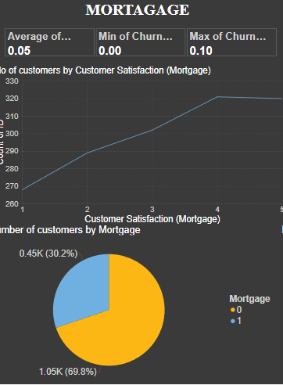

* This whole picture involves a line chart and pie chart and also details regarding checking account churn rates.

1. Churn rates -average churn rate -.05

-min churn rate -0.00

-max churn rate -0.10

Churn rates determine the discontinuation or switching of customer from one product to another so based on these observations reason for the churn rates can be identified and can be reduced.

2.A-line chart measuring the satisfaction of customer of the credit card so different rates of satisfaction is measured on scales whereas 5 highly satisfied ,4-satisfied ,3-as neutral, 2 -as not satisfied ,1 -highly unsatisfied .so we can say that the large number of customers are unsatisfied with the product.

3. The next pie chart determines the participation rate of customers represented as 1,0 where 1 is identified as active and 0 as inactive. The active participation is there which is 71%

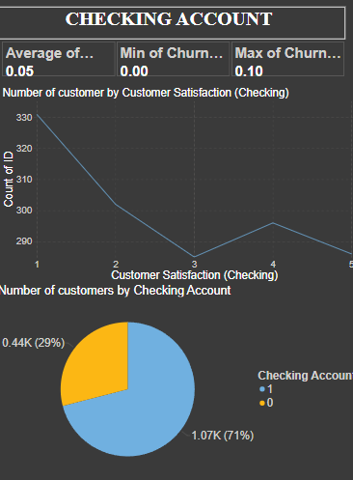

* This whole picture involves a line chart and pie chart and also details regarding saving account churn rates.

1. Churn rates -average churn rate -.05

-min churn rate -0.00

-max churn rate -0.10

Churn rates determine the discontinuation or switching of customer from one product to another so based on these observations reason for the churn rates can be identified and can be reduced.

1. A line chart measuring the satisfaction of customer of the credit card so different rates of satisfaction is measured on scales whereas 5 highly satisfied ,4-satisfied ,3-as neutral, 2 -as not satisfied ,1 -highly unsatisfied .so we can say that the number of customer are satisfied with the product and also a number of customer who are really unsatisfied give a rating 1 so we can identify the reason for their unsatisfaction and can give the best to the customer in order to reach max satisfaction to the customers.
2. The next pie chart determines the participation rate of customers represented as 1,0 where 1 is identified as active and 0 as inactive. so here both active and inactive users are of same rates both positive as well as negative is of same pace.

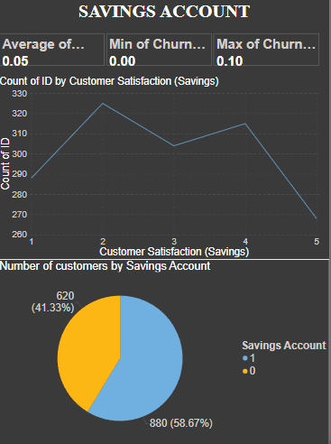

OVERALL RESULT ANALYSIS

* **Targeted marketing campaigns** for specific customer segments and products are analyses such as focusing more on age group of 43, 50 and 69, areas like urban and defend employment status and their product presence.
* **Product development or improvement initiatives**. - Increase penetration rates of existing products and introduce new offerings that resonate with your target audience.
* **Customer retention strategies to address churn** **and improve customer loyalty** - in order to reduce churn rates and also increase the customer satisfaction and loyalty, leading to a healthier customer base and sustainable growth.
* **Product Penetration:** A high percentage of customers use credit cards (733), followed by checking accounts (620) and savings accounts (440). Loan usage appears to be the lowest (107).

Credit cards appear to be the most popular product among this customer base.

There’s a good mix of customers across different employment statuses.

THANK YOU